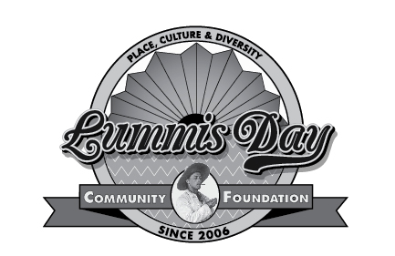
LAUSD Approved (1) Point Credit Class NA-11-54
Two Saturdays, October 13 and 27, 2018 from 8:30 AM to 4:30 PM

The Arroyo Seco culture is characterized by the larger than life persona of Charles Fletcher Lummis, the first city editor of the Los Angeles Times, one of the city’s first male librarians, and founder of the Southwest Museum. Attendees will participate in:
- Field Study and Nature Walk in the restored Lower Arroyo emphasizing the Geography of the Arroyo Seco Watershed
- Instruction in the Sense of Place that Environmental Education restores to all the disciplines with instructors from Audubon and FoLAR
- Learn about the heritage of the inhabitants of the Arroyo from the Tongva and Chumash to the present day and how to use that information to encourage historical, environmental and cultural discovery of your part of the Los Angeles Basin with the students in your classes
- Docent led Tours of the Lummis Home and Gardens as well as the Pueblo Pottery exhibit and the Charles Lummis archaeological exhibit a the Southwest Museum
- Docent led Sycamore Grove Walking Tour for which you are welcome to make arrangements to bring family and friends with you to enjoy this marvelous opportunity
- Teachers will create meaningful, standards-based, curriculum-relevant projects for use in their own classrooms

Workshop Fee: $85.00
Registration form and schedule also available online at www.LummisDay.org
Up to 20 Participants
Registration and Fees Due October 6, 2018
Online registration through Stripe save receipt
“Day of” registration by special arrangement

For more information: Carmela Gomes, gomescarmela@gmail.com (818) 429-8755
_ _ _ _ _ _ _ _ _ _ _ _ _ _ _ _ _ _ _ _ _ _ _ _ _ _ _ _ _ _ _ _ _ _ _ _ _ _ _ _ _ _ __ _ _ _ _
To register by USPS, cut on the line above and return this portion with your check made out to
Lummis Day Community Foundation, Inc with Arroyo Workshop in the note section to:
Carmela Gomes, c/o LDCF, P O Box 50543, Los Angeles, CA 90050
Please Print
Name ______________________________________ (LAUSD Employee # ____________)
School or Office _________________________________
Work Phone ___________________ Home or Cell Phone ________________
Home Address _______________________________ City____________ Zip_________
Email _____________________________________________
N.B. You will be sent materials and directions to all venues prior to October 13, 2018. If you are not able to receive information by email, please indicate that, here.

