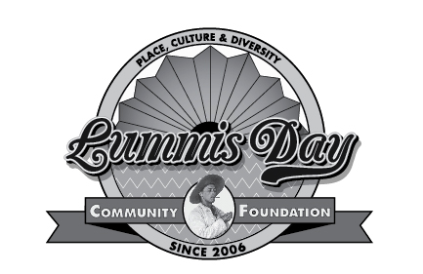
A River Runs Through It:
Charles Lummis and the Culture of the Arroyo Seco
Developing a “Sense of Place” through All the Disciplines
LAUSD Point Credit #NA-11-64
Two Saturdays, October 12 and 26, 2019
Appropriate clothing for both days is casual with good walking shoes.

Saturday, October 12, 2019

8:15AM Assemble in Lower Arroyo Restored Area, Pasadena, for an invigorating walk (wear appropriate clothing and shoes, bring still and video cameras) with Native Plants Expert Christopher Nyerges, Editor “Wilderness Way” Magazine http://www.christophernyerges.com/ and Yim Tam, Instructor.

11:00 AM Assemble – Audubon at Debs Park, 4700 Griffin St., LA 90031 – A Sense of Place and Environmental Education’s Role in all the Disciplines with Keiko Miller, Yim Tam and Carmela Gomes, http://www.debspark.audubon.org/
Lunch provided.

1:00 PM The Lummis Home, 200 East Avenue 43, LA 90031 (enter on Carlotta) – Tour by Docent Christian Rodriguez
2:30 PM Los Angeles River Walk conducted by Instructor from Friends of the Los Angeles River
4:30 PM Adjourn
Saturday, October 26, 2019
8:30 AM Gather at Sycamore Grove Park, 4702 N. Figueroa St, Highland Park, 90042 review project guidelines with Yim Tam, Instructor
9:45 AM Sycamore Grove Walking Tour led by Highland Park Heritage Trust expert docents, Victorian homes, Hiner House and Sousa Nook, http://www.hpht.org/tour.html
12:30 PM Lunch on your own

1:30 PM Assemble at the Southwest Museum, Four Centuries of Pottery with archivist Kim Walters and Lummis in Peru with Archaeologist Karimah Richardson, Hands-on Workshop, Julia Bogany, Tongva Gabrielino Cultural Consultant, Ted Garcia, Chumash/Tatavia Stone Carver and Story Teller

4:00 PM Adjourn

